Design Structure and Flow Influencer Finder

Our system has two types of user blogger and the finder. The blogger will be mentioned as client and finder as the user

1. Home Page

Scroll 0

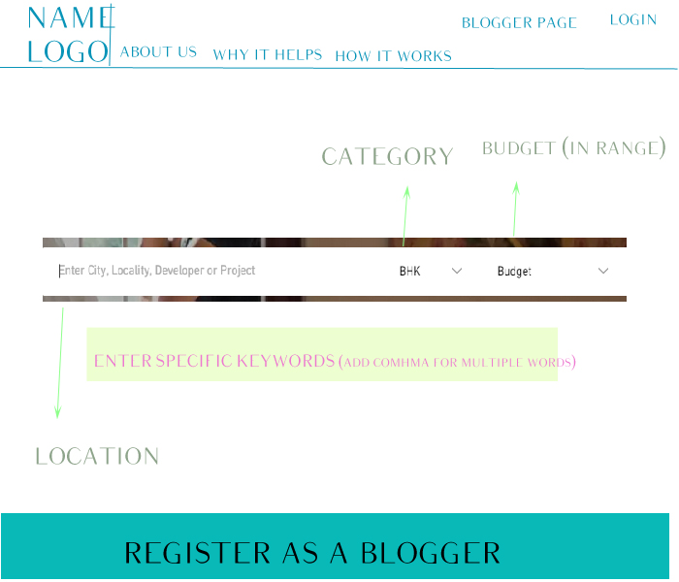

When user enters the site, he will be able to enter his requirement of blogger he needs.

The Requirement options are:

1. Location – User can enter multiple locations or all India
2. Category – It will have options of categories a business belong to. We will give maximum 10 pre-defined categories. There will be an option of multiple category selection
3. Budget – Budget can be entered on a range scale, user can specify max and min
4. Specific Keywords – This section will give user an option to enter any keywords or tags he needs to search in a blogger profile. All bloggers containing those tags will be on top of search result.

There will be two login options for client and user.

Blogger Page and Register as Blogger will direct to the blogger home page.

User Login will pop up a window to enter their credentials.

Why it helps will contain importance of influencer marketing, advantages and how it helps a brand or company.

How it works will have simple infographics that explains how to use the system.

Scroll 1



Why I need a Blogger section will explain what blogging is and how it will benefit the brand

Customer Reviews will have good reviews we received. It will be a horizontal scroll

Scroll 2

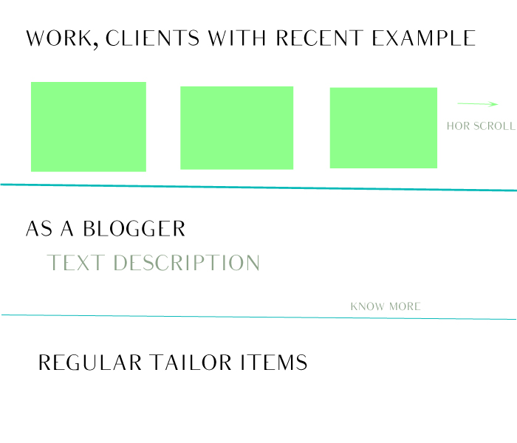

Work, Client – It will contain recent work through bloggers of our page and list of clients

As A Blogger – This section is to make a blogger understand the system and how being registered will us will help him to earn and increase their visibility

Regular Tailor Items – It will contain Support, Help and Contact us links. It will be consistent in all the pages of the site

Blogger Home Page

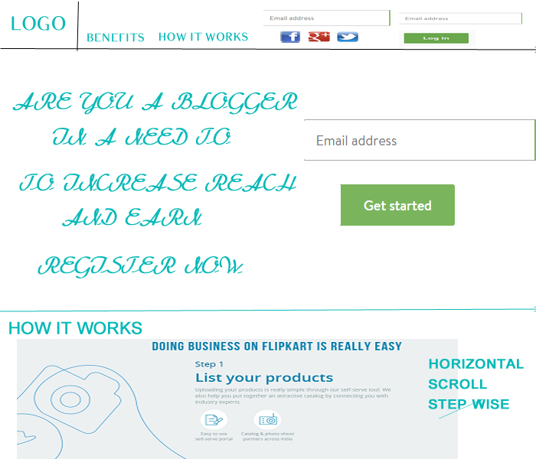

Blogger home page will cater to two types of blogger

1. Registered Blogger
2. New Blogger

Registered Blogger

The goal of a registered blogger is to login to his personal dashboard. On top right corner we have option for the blogger to enter their credential or login through fb, google+, twitter, etc. by clicking on the respective logo.

New Blogger

The goal towards a new blogger is to make him understand the system and its benefits, Educate on how the application works and make him register.

We will have a benefits and how it works tab on top menu. Also, we will have How it works section on home page. It will show the flow of application in a very simple step wise manner. The steps will flow horizontally.

For a blogger to register, we will have a simple single email address field and a Sign Up button. A single field will increase the probability of a new blogger to register, as not much effort needed for first step.

Blogger Register

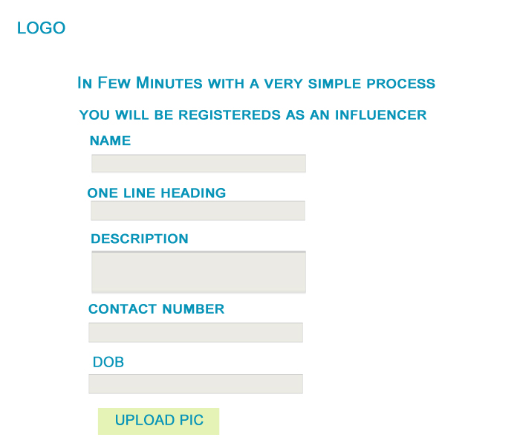

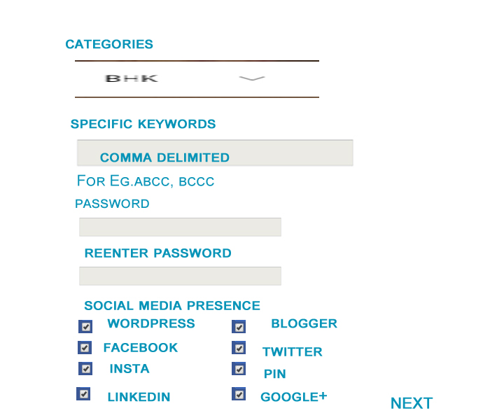

After new blogger enters his email id and clicks on sign up, it enters the first page of setup

In first page of setup, we will fetch basic details of blogger and his presence on social media platform

It is mandatory for a blogger to have an account on either WordPress or blogger

Details on Few Fields

One Line Description – It will be like a heading for blogger home page to attract a user.

Categories – A blogger can select multiple categories for him. All categories will be same as listen on home selection page for user

Specific Keywords – It will contain tag keywords entered by the blogger that covers his domain of work. The tags will be matched through the tags entered by the user on homepage.

Social Media Presence – Blogger will tick on all the platforms he has his presence.

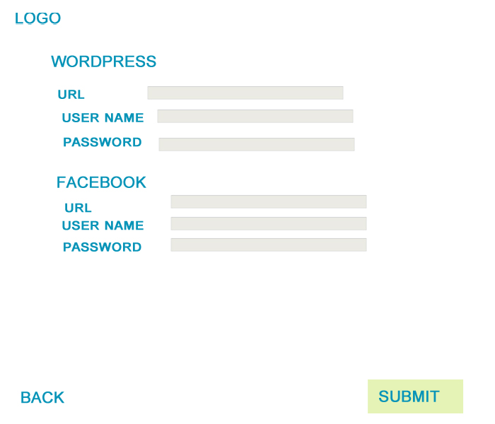

Once blogger clicks next, he will need to enter his all social media platform URL and credentials for validation. In this page only those platforms options would be provided that were ticked by the blogger in previous page.

Back option will be available to go to previous page of entering details.

Submit will finish the process.

All the details will be available to edit by the blogger later on his dashboard.

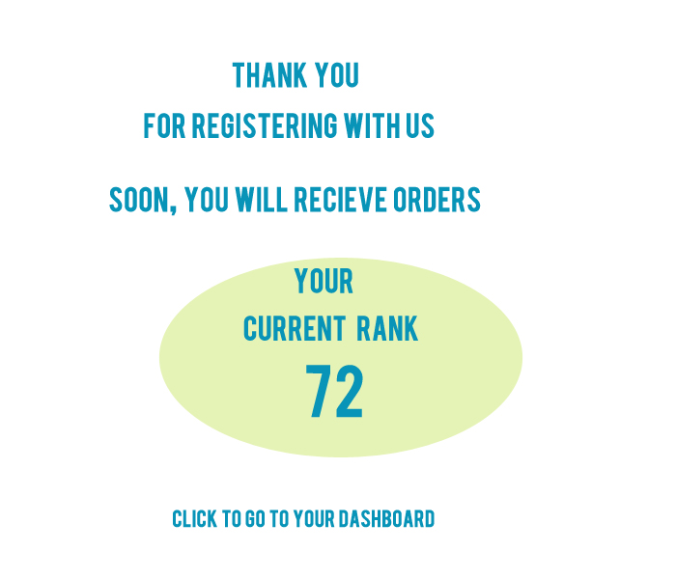

Once blogger submits his details, it will be directed to confirmation page. This page will show his current rank.

While clicking on dashboard he will be redirected to his dashboard.